# Dashboard

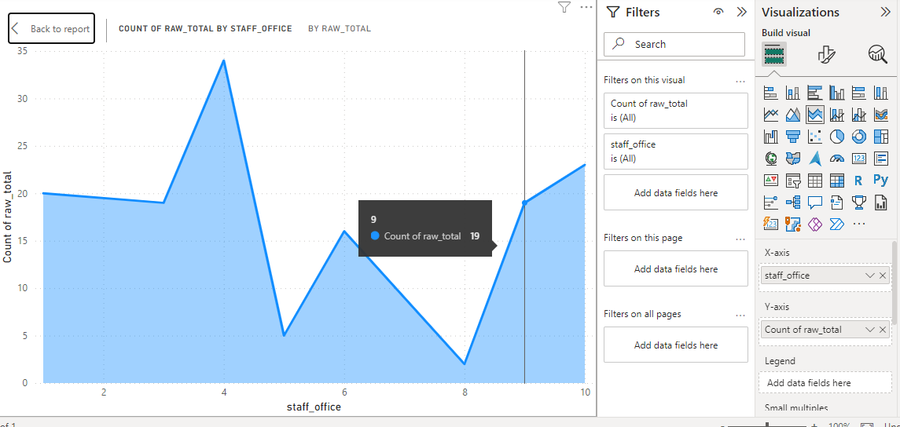

Figure 8 raw total by staff office

In the following comparision the raw total of the staff office is medium in

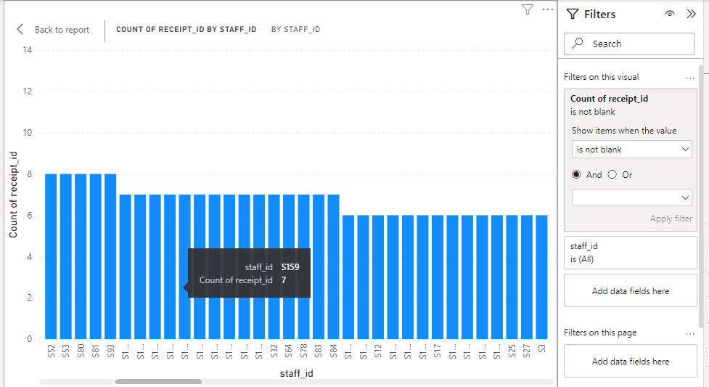

Figure 9 count of receipt by staff id

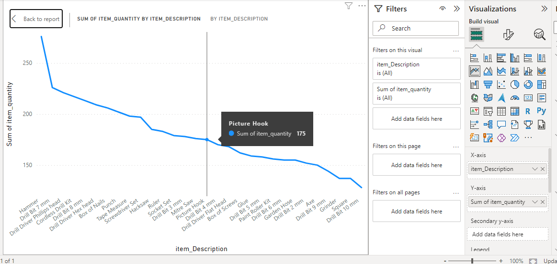

Figure 10 sum of item quantity and item description

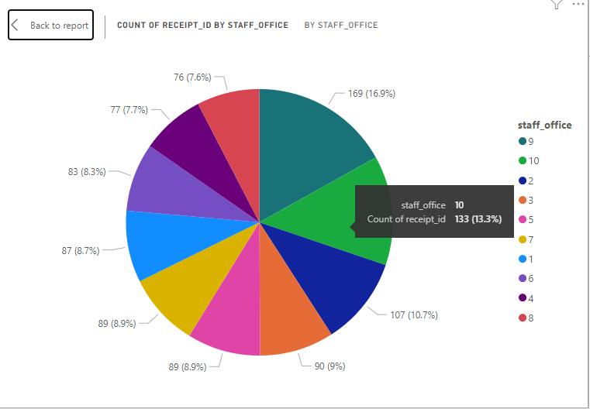

Figure 11 count of reeipt id by staff office